Earth’s Systems Rubric
Parts Working Together to Make a Whole
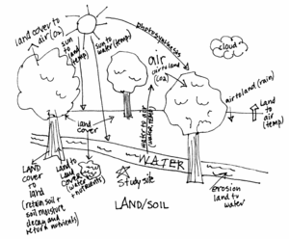

Project Items to be Submitted Due Date:
1) Sample Photograph
- HW: Annotate (title and min. of 10 identifiers)
- Classwork: Identify four interactions. Make reasonable assumptions. Complete sentences.
2) SJN Study Site Photograph
- Classwork/Homework: Annotate and identify interactions using same above criteria.
3) Parts of the Earth System: Inquiry Activity
4) System with Feedback Loop Flowchart

