Name: Class: Date:
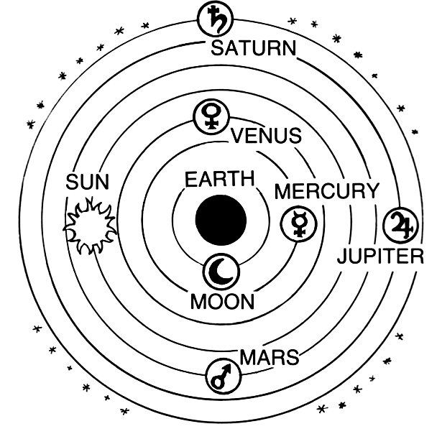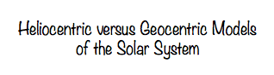

The night sky has been a subject of human curiosity from the earliest civilizations on earth. From Babylonians, Egyptians, Greeks, and Indus all had a fascination for the celestial objects and the elite of the intellectuals built theories to explain the miracles of the heavens. Earlier they were accepted to be from the gods, and later the explanation took more logical and scientific forms.
However, it was not until the development of the Greek culture that proper theories about Earth and the rotation of the planets emerged. Heliocentric and geocentric are two explanations of the arrangement of the universe, including the solar system.
The geocentric model says that Earth is at the center of the cosmos or universe, and the planets, the sun and the moon, and the stars revolve around it. The early heliocentric models consider the sun as the center, and the planets revolve around the sun.
More about Geocentric
The Greek prefix “geo” means “earth.”
The most predominant theory of the structure of the universe in the ancient world was the geocentric model. It says that Earth is at the center of the universe, and every other celestial body rotates around Earth.
The origin of this theory is obvious; it is the elementary naked eye observation of the movement of the objects in the sky. The path of an object in the sky always seems to be in the same vicinity and repeatedly it rises from east and sets from west approximately at the same points on the horizon. Also, Earth always seems to be stationary or motionless and still. Therefore, the closest conclusion is that these objects move in circles around the earth.
Greeks were strong supporters of this theory. History shows that as far back as third century BC, Plato and his student Aristotle wrote works based on the geocentric model. About 140 AD, the Greco-Egyptian mathematician, astronomer, and philosopher further developed the current understanding of the geocentric model by attempting to explain the orbits of the planets. After the death of Ptolemy, the theory lasted for more than 2000 years--unchallenged.
More about Heliocentric
The concept that the sun is at the center of the universe (heliocentric model), also first emerged in Ancient Greece. It was the Greek philosopher Aristarchus of Samos who proposed the theory in third century BC, but it was not taken seriously because of the influence of Aristotle’s view of the universe and lack of proof of the theory at that time.
It was during the Renaissance era that mathematician and Catholic cleric, Nicholaus Copernicus, developed a mathematical model to explain the motion of the heavenly bodies. In his model, the sun was at the center of the solar system and the planet moved around the sun, including Earth. And the moon was considered to move around Earth. Copernicus published his works in 1543.
This changed the way of thinking about the universe and differed from the religious beliefs at that time. The major feature of the Copernican theory can be summarized as follows:
- The motion of the celestial bodies is uniform, eternal, and circular or compounded of several circles.
- The center of the cosmos is the Sun.
- Around the Sun, in the order of Mercury, Venus, Earth and Moon, Mars, Jupiter, and Saturn moves in their own orbits and the stars are fixed in the sky.
- The earth has three motions; daily rotation, annual revolution, and annual tilting off its axis.
- The retrograde motion or the backward motion of the planets is as explained by Earth’s motion.
- The distance from the Earth to the Sun is small compared to the distance to the stars.

Later, in 1609 Johannes Kepler added to Copernicus’s model by producing the elliptical orbits of the different planets revolving around the sun. And, in 1615 Galileo Galilei used his telescope to produce actual evidence of the heliocentric model.
Heliocentric versus Geocentric: what is the difference between the two models?
- In the geocentric model, Earth is considered as the center of the universe, and all celestial bodies move around the earth (planets, moon, sun and the stars).
- In the heliocentric model, the sun is considered as the center of the universe, and the celestial bodies move around the sun.
(During the course of development of astronomy, many theories of geocentric universe and heliocentric universe were developed, and they have significant differences, especially regarding the orbits, but the core principles are as described above.)
Read more: http://www.differencebetween.com/difference-between-heliocentric-and-vs-geocentric/#ixzz2aFd0rsPR
Using the above information, write complete sentences answering the below questions.

1. What does the geocentric model say about the universe?

- What does the heliocentric model say about the universe?

- Why did early astronomers believe in the geocentric model?

- Who developed the heliocentric model and in what year was his works published? And, write three of the summary points of the heliocentric model that you think astounded the world the most during the 1500s.

- Summarize the contributions of the two scientists that provided support for Copernicus’s heliocentric model.

