Chapter 3: Plate Tectonics
STUDY GUIDE

Name: Class: Date:

Section 3.1 Drifting Continents
- What was Wegener’s hypothesis of continental drift?

2. Wegener produced three types of evidence to support his theory of continental drift. What were they? Evidence from

2. What is Pangaea?
3. What is a fossil?

Section 3.2 Sea-floor Spreading
- What technology did scientists use in the mid-1900s to map mid-ocean ridges? Explain the technology?

- What is sea-floor spreading?

- Sea-floor spreading begins where? that form the longest mountain ranges on Earth.
- Explains what happens along mid-ocean ridges for sea-floor spreading to take place?
- Where does subduction take place?
- Why is old oceanic crust more dense than new oceanic crust?

Section 3.2 The Theory of Plate Tectonics
- Earth’s lithosphere is broken into sections called that float on top of Earth’s asthenosphere.
- What is the Theory of Plate Tectonics?

- What do most geologists think cause the movement of Earth’s plates?

- Know the difference between how plates move for:
- Divergent Boundaries
- Convergent Boundaries
- Transform Boundaries
5. Be able to identify boundaries based on a diagram and tell what topographic
feature forms at the boundary.
CONVERGENT BOUNDARY
Oceanic converges with Continental
Continental converges with Continental
DIVERGENT BOUNDARY
Oceanic diverges from Oceanic
Continental diverges from Continental
TRANSFORM BOUNDARY
Rock slides past each other at a fault

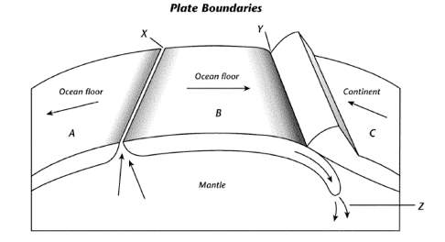

What occurs at X?
What underwater land feature is at X?
What occurs at Y?
What underwater land feature is at Y?
What is happening at Z?

Short Answer:
Cite evidence from a landform and fossil to support the hypothesis that Africa and South America were once joined?

